COMHAIRLE CHONTAE LONGFOIRT

LONGFORD COUNTY COUNCIL

Corporate Affairs,
Aras an Chontae,
LONGFOIRT.

12u Márta 2014.

Chuig: Gach Ball don Chomhairle.

A Chomhairleoir,

Iarrtar ort bheith i láthair ag Cruinniú Míosuil Chomhairle Chontae Longfoirt a tionólfar i Seomra na Comhairle, Aras an Chontae, Longfoirt ar an Chéadaoin,
19u Márta 2014 ag 4.00 p.m chun gnó a dhéanamh d’réir an Chláir thíos.

You are requested to attend the Monthly Meeting of Longford County Council to be held in the Council Chamber, Aras an Chontae, Great Water Street, Longford, on Wednesday, 19th March 2014 at 4.00 p.m. to transact business, as set out on the Agenda hereunder.

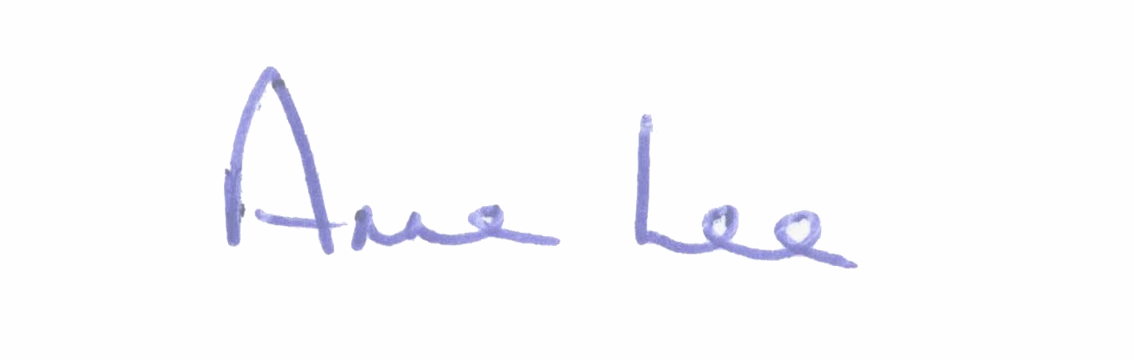
Mise le meas,

_______________
Anne Lee,
Meetings Administrator.

C L A R

Prayer before Meeting.

- Confirmation of Minutes of the following Meetings of Longford County Council:-

(a) Monthly Meeting held on 19th February 2014.
(b) Adjourned Monthly Meeting held on 27th February 2014.
(copies enclosed)

2. Matters arising from Minutes.

3. Presentation by the Irish Deaf Society in relation to the official recognition of the use of sign language within the Irish Constitution.

4. To note adopted Minutes of Corporate Policy Group Meetings held on
6th and 15th January 2014 - copies enclosed.

5. To note County Manager’s Orders. (Summary herewith).

6. Finance & Information Systems, Housing & Building.

- To note Public Liability Claims received during February
2014 – report enclosed.

- Consideration of Annual Financial Statement 2013 - enclosed.

- Consideration of Approval to Additional Expenditure under S104(7)
of the Local Government Act 2001 – details enclosed.

(d) Consideration of disposal of property at Bawn, Drumlish, Co. Longford to Laszlo Kozma & Fiona McTiernan in accordance with the terms of Section 183 of the Local Government Act 2001 issued on the
3rd March 2014.

7. Economic and Community Development, Corporate, Cultural & Recreational Services, Human Resources, Planning & Building Control.

(a) Consideration of Planning Applications received since February meeting of the Council.

(b) Presentation of 2013 Annual Report of Longford County Council
Audit Committee by Ms. Karen Clabby, Chairperson Audit
Committee - 2013 Annual Report enclosed.

(c) To note Building Control (Amendment) Regulations 2014 - report enclosed - deferred from February meeting.

- Consideration to provision of support by way of guarantee to Granard Visitors Centre project.

(e) (i) Local Elections 2014 - To consider the issuing of Polling Information Cards to Local Electors.

(ii) Local Elections 2014 (Disclosure of Donations and Expenditure) - Guidelines for Candidates – Copy Attached

(f) Notice of Motion submitted by Councillor Denis Glennon.

“That the report commissioned by this Council, through the Institute of Public Administration, a number of years ago and to which many Councillors made oral submissions be provided to Councillors before the end of the life of this Council.”

8. Infrastructural, Environmental & Emergency Services.

(a) To note minutes of the following Area Committee Meetings -
  - Longford Local Electoral Area Committee meetings held on
1st October and 5th December 2013.
- Ballymahon Local Area Committee meeting held on
8th October 2013.
- Granard/Drumlish Local Area Committee meeting held on
23rd September 2013.

- To note minutes of Transportation, Road Development & Maintenance and Road Safety Policies Strategic Policy Committee Meetings held on 23rd September and 10th December 2013 - copies enclosed.

- Notices of Motions submitted by Councillors, as listed hereunder –

Councillor Tom Victory.

“That Longford County Council would carry out checks in illegal dumping black spot areas for evidence of disposing of household waste legally.”

Councillor Denis Glennon.

“That Longford County Council asks that the National Roads Authority to implement the following Road Safety Measures over the coming years -

- According to the Road Safety Authority (RSA) as many as one in five fatal road accidents are as a consequence of driver tiredness or fatigue.
One of the RSA recommended, indeed obvious, actions that should be taken by tired drivers is to pull into a safe place and rest.
This council proposes that the NRA provides a far greater number of safe and secure lay-bys on our National Primary Road Network and in particular our dual carriageways as the existing few are wholly insufficient and too far apart.
(b) That the remains of blown out tyres on our Road Network be removed immediately after the tyre has been replaced and not ` left for days as currently appears too often to be the case, thereby posing a serious risk to other road users.”

“Now that domestic water must be paid for by the user in the near future, that this Council requests that Irish Water provide practical and detailed water conservation guidelines to every householder in Ireland so that people can start putting these conservation measures into practice in advance of the implementation of water charges and not just rely on website guidelines.”

9. General Items.

(a) Correspondence

- Letter dated 10th February 2014 received from the Office of the Minister for Health regarding “Walk In Medical Card Offices.”

- Letter dated 20th February 2014 received from the Office of the Minister for Justice & Equality regarding Garda vetting.

- Letter dated 21st February 2014 received from the Office of the Minister for the Environment, Community & Local Government regarding the future of community and rural development in Longford.

- Letter dated 25th February 2014 received from the Office of
Mr. Pat Rabitte, T.D., Minister for Communications, Energy and Natural Resources regarding the roll out of natural gas to Longford.

(v) To note letter dated 27th February 2014 received from the Office of the Minister for Housing and Planning regarding the following issues -

    - Local Property Tax/Local Property Tax on Social Housing.
    - Housing Adaptation Grant Schemes for Older People and People with a Disability.
    - Building of OPD’s.

(vi) Letter dated 7th March 2014 received from the Office of the Environment, Community & Local Government regarding Funding for Repairs and Associated Costs following Severe Weather from the 13th December 2013 to 6th January 2014.

(copies enclosed)

(b) Notices of Motions submitted by Councillors, as listed hereunder -

Councillor Barney Steele.

“I am requesting the I.D.A. to focus more on County Longford.
There appears to be an improvement in inward investment into Ireland and that is welcome, but it is no different than before. The focus is on Dublin, Cork and other larger towns.

The closest mention County Longford got was that the I.D.A. are looking at Athlone. Longford is in need of some help. I propose that representatives from the I.D.A. be invited to a County Council meeting.

“Are any hotel chains enquiring or showing any interest in locating in County Longford?

“The effects of the closure of Connolly Barracks is very evident on Lower Main Street in Longford town. I propose that Longford County Council requests the Government to relocate a Government Department to compensate for the loss of the Army Barracks.”

10. Votes of sympathy.

11. Conferences -
Consideration of Report from Corporate Policy Group.

